SeaLife Tech advice
Advice for Authorized SeaLife Service Centers

Date: July 1, 2009

Subject: Delete button or Menu button activates automatically at depth.

Applies to: DC800 and DC1000

Symptoms: The inner-camera DELETE or MENU button is automatically activated at depths greater than 50 meters. A message appears on the LCD display - “Delete This Picture? YES / NO” or the Menu screen appears. The diver needs to ascend to deactivate the Delete or Menu button.

Cause: The DC800/DC1000 housing Delete and Menu button assemblies use a “reach”, which makes contact with the inner-camera Delete or Menu button when the user pushes the housing button.
Menu “Reach”
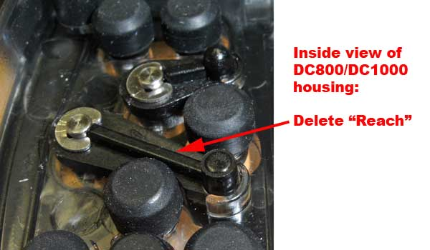

The heights of the DC800/DC1000 inner camera delete and menu buttons vary. DC800 inner-cameras produced before September 2008 have a “low” button height and DC800/DC1000 cameras shipped after September ’08 have a “high” button height:

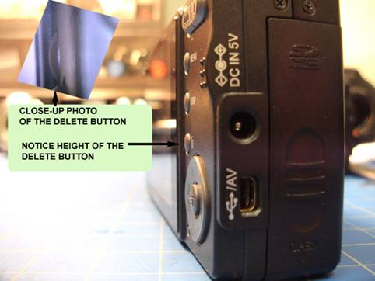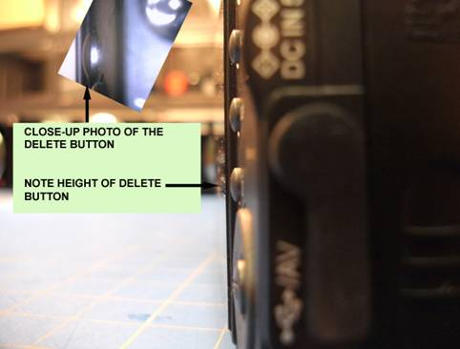
This camera has a “LOW” button height This camera has a “HIGH” button height

The reach is designed to work with LOW or HIGH button heights, but for some cameras with a HIGH Delete or Menu button it may be possible for the “reach” to contact the inner-camera’s delete and menu button at depths greater than 50 meters [without the user pushing the button].

Scope: This problem MAY OCCUR with cameras that have a HIGH Delete or Menu button. It only effects a small percent of these cameras AND users who dive more than 50 meters.

Solution: SeaLife has solved the problem in May 2009 by modifying the Delete and Menu reach. Authorized SeaLife Service Centers should replace the Delete and or Menu Reach for any customer who has experienced this problem. SeaLife does not recommend replacing the delete or menu reach in their inventory. NEVER replace the delete or menu reach for inner-cameras with a “Low” delete button height. SeaLife will provide free Delete and Menu Reaches and E-clips to all authorized service centers.

For video instructions on replacing the delete reach, please visit YouTube:
http://www.youtube.com/watch?v=FZXb_zESik4

Note: After replacing the Delete or Menu Reach, test the housing with camera inside on land. Make sure the delete and menu reach activates the inner camera delete and menu button on land. If the delete or menu button is not functioning on land, replace the housing.

Warranty: Yes

